You miss to mention one element in financial statements part which is break-even analysis
Please you should provide table and graph

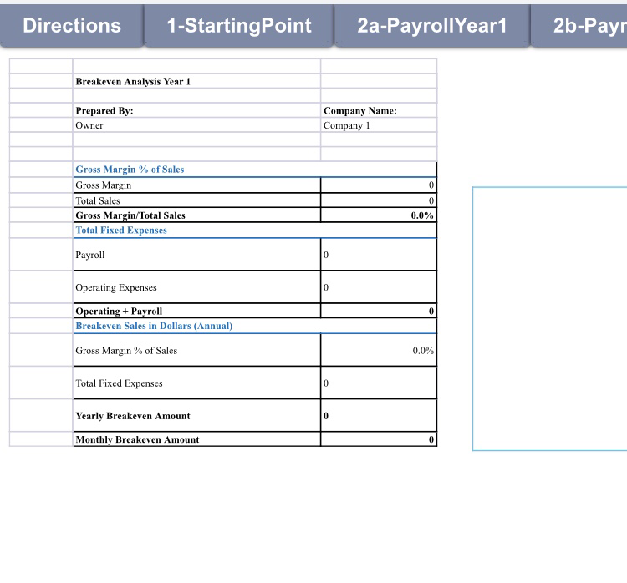
I will attach screenshot of an example of break-even analysis pleas check it

